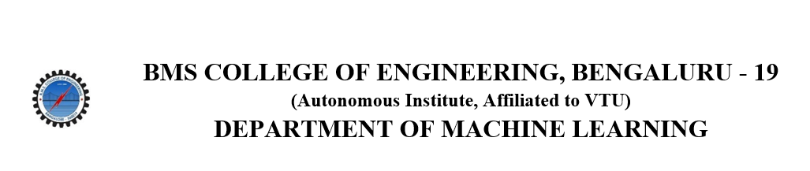
ACTIVITY REPORT
ON
CLOCKED OUT
- Name of the Club: BMSCE ACM STUDENT CHAPTER
- Name of the Activity: Clocked Out
- Objectives: The BMSCE ACM Student Chapter organized an event on the account of Utsav, Clocked Out, this event’s aim was to challenge participants across multiple dimensions of strategy, memory, reflex, and logic. The event aimed to promote critical thinking, teamwork, and competitive spirit.
- Date, Time & Venue of the Activity:
EVENT | Clocked Out
DATE/DAY | Friday, 9th May 2025
TIME | 9:00 am to 1:00 pm
VENUE | 2nd Floor PJA Block, Common Area
- Name and details of collaborating agency (if it is collaborative/joint activity): None
- Brief summary of the Event:
Clocked Out was a fun and challenging three-round competition designed to test how well participants could think quickly, plan smartly in tricky situations, and solve clever puzzles.
In Round 1, called Point Acquisition – Mini-Game Marathon, players took part in three exciting mini-games to collect points. In ChronoSort, they had to arrange numbered cards in the correct order as fast as possible. Nerf Nexus was a dart game where players could take risks using harder challenges to possibly double their points. Picture It tested memory by showing items briefly, then asking players to recall details. The points earned in this round were very important for moving ahead and came in handy later to unlock clues or mess with other teams.
Round 2 was The Barter of Relics, a card trading game with a twist. Players got cool-looking fictional cards based on Marvel and sci-fi themes, but they didn’t know how valuable each card really was. They had to trade using their gut, charm, and strategy. At the end, the hidden values of the cards were revealed, which changed everyone’s scores and decided who stayed in the game.
Round 3, The Final Convergence, brought it all together with a riddle-solving race. Teams faced a series of connected riddles based on five deep themes. Solving each riddle required spending their hard-earned points. They could also use special power-ups to delay or confuse their rivals. The event ended with a thrilling sprint to solve the final mystery first.
- Outcomes: The event helped participants improve their skills in strategy, memory, logic, and teamwork. It offered a fun yet competitive atmosphere with a variety of game formats that kept everyone engaged. Players got the chance to interact, collaborate, and build connections, whether playing solo or in teams. It also pushed them to think creatively and stay flexible under pressure. Overall, the event set a solid base for future interactive activities that blend entertainment with thoughtful challenges.

- Number of participants and volunteers :
Number of Volunteers | Number of Registered teams
6 | 33

- Photographs of the event:
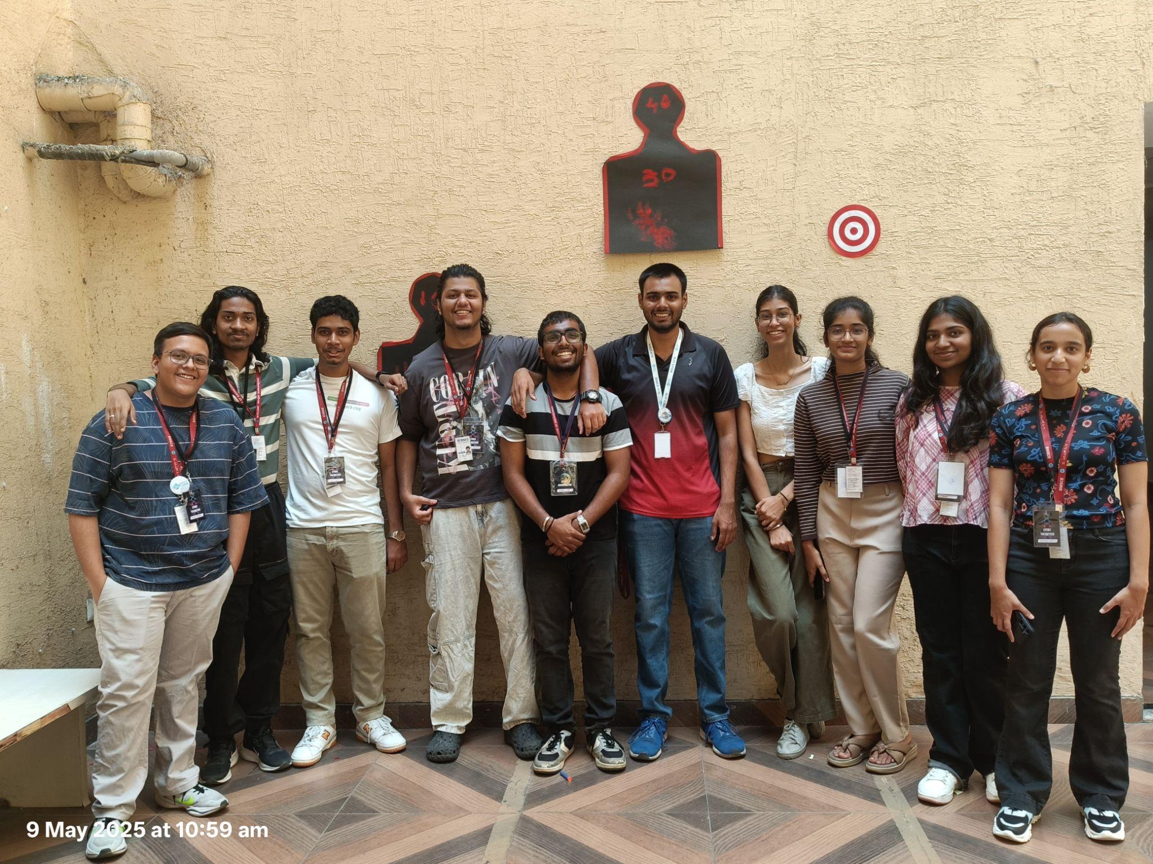

- Supporting Documents:
a. Circulars/Brochures:
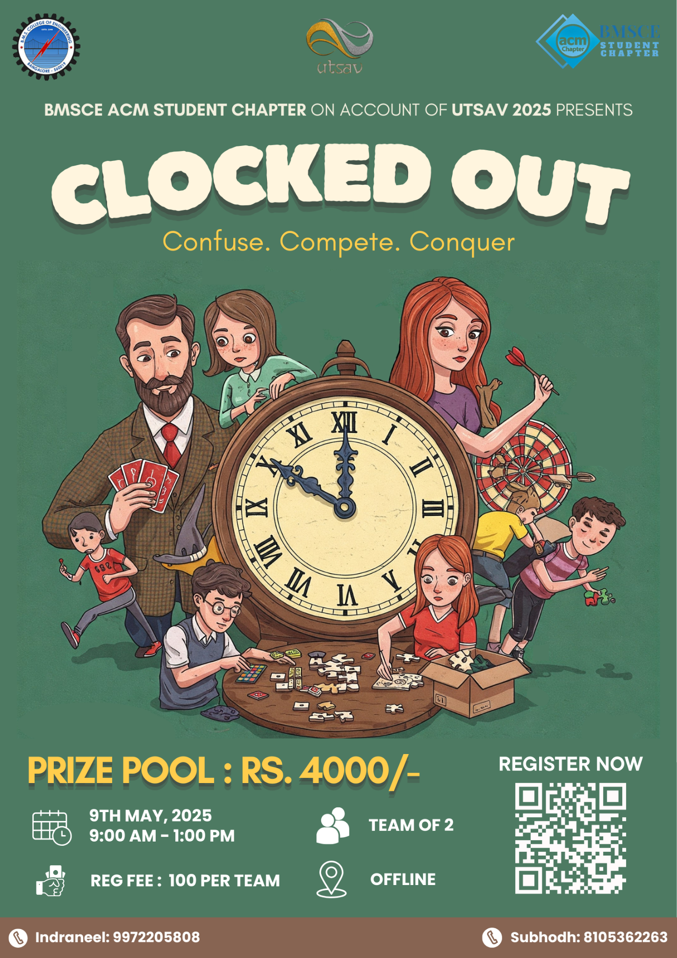

b. Attendance:
Player 1 Name | Player 1 Phone number | Player 1 email | Player 2 Name | Player 2 Phone number | Player 2 email
Yashitha.V | 8618919102 | yashithav.cs24@bmsce.ac.in | Zakkam Deepthi Srujana | 9346055961 | deepthisrujana.cs24@bmsce.ac.in
Devraj | 8296018389 | cdevaraj0018@gmail.com | Chiranthana S P | 9964877779 | chiranthanasp007@gmail.com
Dasari lalit | 9663566010 | dasarilalit.ai24@bmsce.ac.in | Dilasha Tamang | 9582494028 | dilashatamang.ai24@bmsce.ac.in
G.Vignesh | 7989597468 | gandlavignesh.ai24@bmsce.ac.in | Rakshita K R | 8073899774 | rakshitakr.cs24@bmsece.ac.in
Neelam Mridhvik reddy | 6363369592 | mridhvikreddy.ai24@bmsce.ac.in | Navaneeshwar | 9154276356 | navaneeshwar.ai24@bmsce.ac.in
Sanath S Shetty | 7676206958 | sanaths.cs23@bmsce.ac.in | Thilak K | 7337807677 | thilakk.cs23@bmsce.ac.in
Tejaswara Raju | 8328383514 | tejeswararaju.ai24@bmsce.ac.in | Nalamaru Haratejas | 8688783150 | haratejas.ai24@bmsce.ac.in
Paleti Grishma Sree | 9704858364 | grishmasree.ai24@bmsce.ac.in | Praneetha | 9346708789 | saipraneetha.cs24@bmsce.ac.in
Tejas Bhimani | 9353973742 | Tejasbhimani.ci24@bmsce.ac.in | Kanav Patel | 7019658773 | Kanavpatel.ci24@bmsce.ac.in
Puneeta Thareja | 9416290847 | puneetathareja.ai24@bmsce.ac.in | Navami vinod patil | 7022265326 | navamivinod.ai24@bmsce.ac.in
ANKUR RAJ | 9102622523 | rajankurpt@gmail.com | DEEPAK B V | 8431737904 | deepakbvnaik@gmail.com
Chiranth GH | 8073920625 | chiranthgh.ai24@bmsce.ac.in | Goutham kumar KS | 9663706019 | gouthamkumar.ai24@bmsce.ac.in
Shreenivas Ganapati Naik | 7899955280 | shreenivasnaik280@gmail.com | Siddesh C | 6362314656 | siddeshcsiddu364@gmail.com
Prajwal.S | 8431894559 | sprajwal149@gmail.com | Chandana.N | 9019359993 | chandananagesh2311@gmail.com
Aneesha Manjunath Iyer | 8762517907 | aneeshamiyer@gmail.com | Batul H Suratwala | 8073291832 | batulspams@gmail.com
Praneeth Nandan. R | 8951669480 | praneethnandan.ai24@bmsce.ac.in | Adwi. H. S | 7019420887 | hsadwi.ai23@bmsce.ac.in
Agasthya | 7019398048 | agasthyaajit@gmail.com | Ananya | 8660722836 | ananya08bharadwaj@gmail.com
Naysha Navin Shrivastava | 9154260804 | nayshanavin.cs24@bmsce.ac.in | Fazal | 9972205808 | fazalmohammad.ai24@bmsce.ac.in

